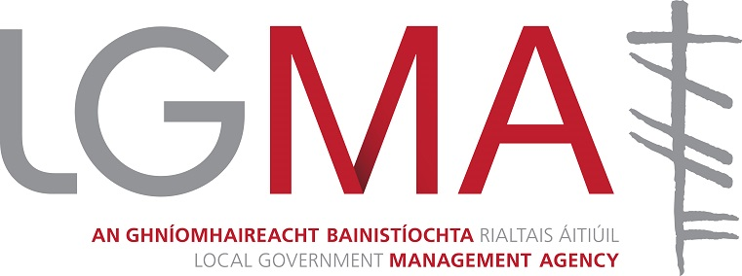

Clerical Officer
Grade 3

Information Booklet for Candidates

Please Read Carefully Before Applying

Closing Date: – Friday, 8th November 2019 by 5.00pm

The Local Government Management Agency is committed to a policy of equal opportunity.

Contact

Human Resources (Internal)
Local Government Management Agency
Local Government House, 35-39 Ushers Quay, Dublin 8 D08 XKP7

Telephone: (353) 1 633 2200
Email: jobapplications@lgma.ie
www.lgma.ie

Local Government Management Agency

The Organisation

The Local Government Management Agency (LGMA) is a state agency established in 2012 following the merger of the Local Government Management Services Board (LGMSB), the Local Government Computer Services Board (LGCSB) and the integration of An Comhairle Leabharlanna (The Library Council) functions.
The LGMA is an agency of Local Authorities, primarily funded by Local Authorities, and operates in the local government sector, reporting on performance as required to the Department of Housing, Planning, and Local Government.
The Agency aims to meet the needs of Local Authorities and the Department of Housing, Planning and Local Government (DHPLG) in delivering on the public sector reform agenda in the local government sector (particularly in terms of sectoral approaches to service delivery), researching emerging and identified issues, assisting Local Authorities in the implementation and measurement of change, and supporting, in general, enhanced performance by the local government sector.

The statutory remit of the Agency extends to include:

- The delivery of advisory services to Local Authorities to assist and co-ordinate the business of these Local Authorities;
- The delivery of such services as may be required by Local Authorities in the Industrial Relations (IR) and Human Resource Management (HR) domain;
- The delivery of such services as may be required by Local Authorities for the purpose of coordinating and securing compatibility in, the use of Information and Communications Technologies (ICT);
- The provision of advice, assistance and services to Library Authorities in relation to the public library service;
- The provision of such other management services as may be required by Local Authorities;
- The provision of such services for meetings of Local Authority Chief Executives and such other support services required by the County and City Management Association (CCMA);
- The provision of such services as required as Registrar of Public Lending Remuneration;
- The provision of such advice, information and assistance required by the Minister of Housing, Planning and Local Government.

Governance
The Government’s ‘Action Programme for Effective Local Government – Putting People First’, confirms local government as the primary means of public service at local level and identifies the sector as key to promoting local community, social and economic development. The current structure of local government in Ireland comprises 31 Local Authorities with separate responsibility for the delivery of a wide range of services in their local area with a focus on making their respective towns and cities attractive places to live, work and invest.

These services generally include housing; planning; roads; water supply; local economic development; environmental protection; provision of recreation and amenities and community infrastructure. The Local Government Management Agency is a vehicle of the local government sector, working for Local Authorities with Local Authorities.

The LGMA conducts its business in accordance with the rules, regulations and accountabilities which govern State Agencies in Ireland. In that regard a Council of the Board of the Agency has oversight through the Board and its committees. The Council of the Board, comprising the chief executives of the 31 Local Authorities appoint 8 members; and the Minister for Housing, Planning and Local Government appoint three members to the Board. The business of the Agency is facilitated by a series of sub-committees, detailed below, recognising the obligations of the Service Level Agreement with the Department of Housing, Planning and Local Government.

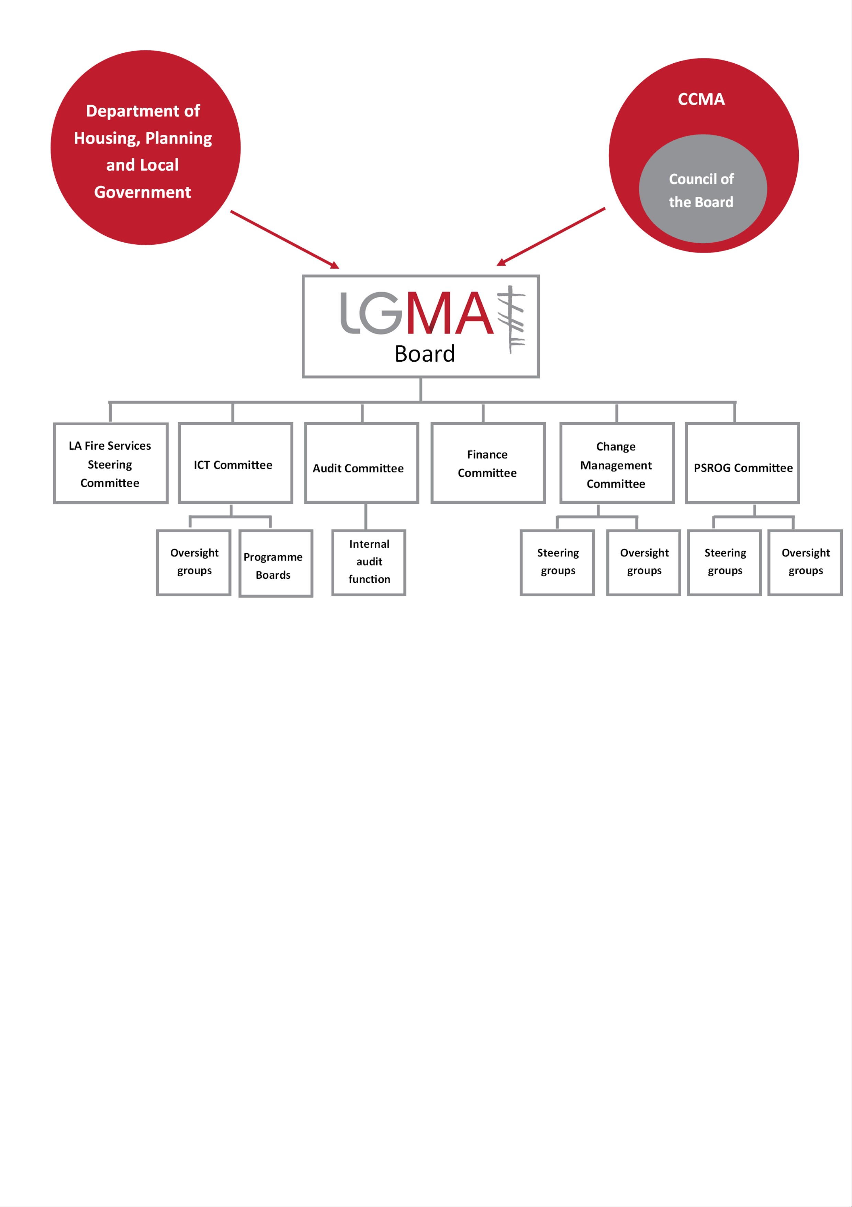

CLERICAL OFFICER (GRADE 3)

Role of the Clerical Officer
The Clerical Officer role is a key support position within the LGMA and is assigned to a service delivery (e.g. Programme Management & Innovation, Organisation Support, Strategy Research & Communications) or internal support functional area (e.g. Corporate Services, Finance, HR) as required.

The role provides a comprehensive general administrative and clerical support to a section, department or division and assists with the smooth, efficient and professional operation of the business area. The role involves supporting managers and colleagues and working as part of a team in meeting work goals and objectives and delivering quality services to internal and external customers.

The duties of a Clerical Officer are varied and can involve assignment to different parts of the organisation or different areas of work. The performance of the entire range of duties is not necessarily confined to any one individual within a section, as the work requires that employees in the role, function in a flexible manner and work effectively together as a team to deliver required outcomes or outputs.

The post holder will work under the direction and management of a designated official and the following reflects the typical duties required of the post holder:

- General clerical work e.g. filing, photocopying, answering/making telephone calls, dealing with emails, meeting/ event support, database administration etc. under the supervision of a designated manager;
- Supporting line-managers and colleagues;
- Working as part of a team in delivering business support services;
- Communicating and dealing with the public/customers e.g. responding to queries and providing information face-to-face, by telephone or via email;
- Using Information Technology on a daily basis e.g. word processing, spreadsheets, database, email, internet and LGMA intranet and extranet;
- Providing cover to the LGMA reception and switchboard on a rota basis as required, greeting visitors, booking meeting rooms, registering post and providing other reception services as required;
- Coordinating and attending meetings, taking minutes and preparing draft minutes as required;
- Assisting with the preparation and running of events;
- Maintaining high quality records/ databases and circulation lists in a thorough and organized manner;
- Maintaining confidentiality of documents and materials as appropriate, at all times;
- Providing research support as required, including obtaining and collating information;
- Carrying out routine accounts work;
- Input to LGMA corporate initiatives, as required;
- Carrying out any other duty that may be assigned from time to time by the Line Manager.

Essential Requirements for Clerical Officer, Grade III
- Character
Each candidate must be of good character.

- Health
Each candidate must be in a state of health such as would indicate a reasonable prospect of ability to render regular and efficient service.

- Education, Training, Experience etc.
Each candidate must have a good general level of education.
and
- Demonstrate the competencies set out in Appendix 1

Desireable requirements for Clerical Officer Grade III
The ideal candidate will demonstrate:

- Understanding of the role of a Clerical Officer;
- Relevant administrative experience and clerical skills;
- Strong customer service ethos;
- Knowledge and experience of operating ICT systems;
- Be self-motivated and an effective communicator;
- Be able to work under pressure, to tight timelines, effectively and flexibly, as part of a team.
- Hold a HR qualification
- Have Payroll experience

- Other Eligibility Criteria

Eligibility to Compete and Certain Restrictions on Eligibility
Candidates should note that eligibility to compete is open to citizens of the European Economic Area (EEA). The EEA consists of the Member States of the European Union along with Iceland, Liechtenstein and Norway. Swiss citizens under EU agreements may also apply. Other candidates may be eligible to compete subject to their having or obtaining an appropriate work permit for the nature and duration of the position.

Former Public Service Employees
Eligibility to compete may be affected where applicants were formerly employed by the Irish Public Service and previously availed of an Irish Public Service Scheme including:

- Incentivised Scheme for Early Retirement (ISER)
- Department of Health and Children Circular (7/2010)
- Collective Agreement: Redundancy Payments to Public Servants

Applicants should ensure that they are not precluded from re-engagement in the Irish Public Service under the terms of such Schemes. This is a non-exhaustive list and any queries should be directed to the applicant’s former Irish Public Service Employer in the first instance.

Declaration
Applicants will be required to declare whether they have previously availed of a public service scheme of incentivised early retirement and/or the collective agreement outlined above. Applicants will also be required to declare any entitlements to a Public Service pension benefit (in payment or preserved) from any other Public Service employment and/or where they have received a payment-in-lieu in respect of service in any Public Service employment.

Key relationships or interpersonal contacts

- Within the organisation:

Level | All Staff
Type of contact | All types – in person, meeting, telephone, video conferencing, e-mail, written
Frequency | Daily, weekly, monthly and as and when required
Purpose | Multi-purpose connected with the functioning of the Agency

- External (including other bodies, the media and the general public):

Type of Organisation/  Person Contacted | Senior personnel in Local Authorities, Central Government Departments, State Agencies, National Public and Private Sector Bodies and suppliers of products and services to the Local Government sector and the LGMA.
Type of contact | In person, meetings, conferences, video conferences, telephone, e-mail, written
Frequency | Daily, weekly, monthly as and when required
Purpose | Support, advice, knowledge/information sharing, influencing and negotiation.

The Application and Selection Process

How to Apply

Applications must be made on the official application form only in typed format only and all sections must be completed in full. When completing the application form accuracy is essential. The information you supply in the application form will play a central part of the selection process.

The completed application form(s) must be forwarded so as to reach the
The Local Government Management Agency
Local Government House, 35-39 Ushers Quay, Dublin 8

not later than 5pm on Friday, 8th November 2019

Applications must be emailed directly to jobapplications@lgma.ie

If you do not receive an acknowledgement of receipt of your application within two working days of applying, please check your Junk/Spam folders as email notifications may be filtered into your Junk/Spam email folders. Any other queries regarding your application form should be emailed to jobapplications@lgma.ie.

Selection Process

Shortlisting exercise
The Agency reserves the right to shortlist applications based on the information supplied in the application form. In the event of a shortlisting exercise being employed, the Interview Board will examine the information provided in your application, assess it against the criteria based on the requirements for the position and decide if you will be shortlisted, relative to the other candidates applying for the position.

Competitive main interview
Admission to the Selection Interview is conditional on receipt of a completed application form by the required cut-off date.

The onus is on all applicants to make themselves available for the obligatory interview on the date specified by the LGMA and to make whatever arrangements are necessary to ensure that they receive communications sent to them at the address specified on their application form. Interviews will be conducted by an Interview Board set up by the LGMA. The Interview Board will assess the merits of candidates. Only candidates who reach such a standard as the Interview Board consider satisfactory in the competitive interview will be considered for selection.

Before being recommended for appointment candidates will satisfy the Interview Board that they possess the requisite knowledge and ability for the proper discharge of the duties of the position.

Candidates will be assessed under the following competency headings:

- Customer Focus
- Planning and organising work
- Personal Effectiveness

Feedback and review
Candidates have the right to seek feedback from their interview. Should a candidate be unhappy with an action or decision in relation to their application for appointment, they have the right to seek a review of the process. This request must be made within 5 working days of receiving notification of the decision on their application.

Panel
A panel may be formed on the basis of such interview. Candidates whose names are on a panel and who satisfy the LGMA that they possess the qualifications declared for the office and that they are otherwise suitable for appointment may with the life of the panel be appointed as appropriate vacancies arise. The life of the panel will not be more than one year, unless extended.

Candidates should note that canvassing will disqualify.
Principal Conditions of Service

General
The appointment is to a permanent post in the Local Government Management Agency and is subject to general terms and conditions in operation relating to appointments in the Agency.

Remuneration
The salary scale applicable to this position is as follows:

Point No. | 1 | 2 | 3 | 4 | 5 | 6
Salary | €24,000pa | €25,576pa | €25,966pa | €26,753pa | €27,903pa | €29,057pa
Point No. | 7 | 8 | 9 | 10 | 11 | 12
Salary | €30,210pa | €31,047pa | €32,156pa | €33,261pa | €34,045pa | €35,142pa
Point No. | 13 | 14 | LSI1
Salary | €36,244pa | €38,320pa | €39,793pa

The salary shall be fully inclusive and shall be as determined from time to time. The holder of the office shall pay to the LGMA any fees or other monies (other than his/her inclusive salary) payable to or received by him/her by virtue of his/her office or in respect of services which he/she is required by or under any enactment to perform.

Important Note
Entry will be at the minimum of the scale i.e. €24,000pa and the rate of remuneration will not be subject to negotiation and may be adjusted from time to time in line with Government pay policy. Different terms and conditions may apply if you are currently a serving civil or public servant.
Subject to satisfactory performance increments may be payable in line with current Government Policy.

Tenure
The position of Clerical Officer, Grade 3 is full-time and permanent.

Hours of Attendance
Hours of attendance will be as fixed from time to time. Typically, hours will be of the order of 37 hours per week. The position holder will be required to work a five-day week. The LGMA currently have a flexible working hour attendance scheme in operation.

Location
An officer’s headquarters shall be such as may be designated from time to time. At present the LGMA has offices at two locations in Dublin. When absent from home or headquarters on official duty appointees will be paid appropriate travelling expenses and subsistence allowances, subject to normal regulations.

Annual leave
The Annual Leave allowance for New Entrants is 30 days. This allowance is subject to the usual conditions regarding the granting of annual leave in the LGMA, is based on a five-day week and is exclusive of the usual public holidays.

Sick Leave
Pay during properly certified sick leave absence will apply, in accordance with the provisions of the Public Service Sick Leave Scheme, 2014.

Superannuation and Retirement
The successful candidate will be offered the appropriate superannuation terms and conditions as prevailing in the Public Sector, at the time of being offered an appointment. In general, and except for candidates who have worked in a pensionable (non-single scheme terms) public service job in the 26 weeks prior to appointment, this means being offered appointment based on membership of the Single Public Service Pension Scheme (“Single Scheme”). Key provisions attaching to membership of the Single Scheme can be found at www.per.gov.ie/pensions

Persons who become pensionable officers of the LGMA, who are liable to pay the Class A rate of PRSI contribution will be required in respect of their superannuation to contribute to the LGMA at the rate of 1.5% of their pensionable remuneration plus 3.5% of net pensionable remuneration (i.e. pensionable remuneration less twice the annual rate of social insurance old age contributory pension payable at the maximum rate to a person with no adult dependant or qualified children).

Persons who become pensionable officers of the LGMA who are liable to pay the Class D rate of PRSI contribution will be required, in respect of their superannuation, to contribute to LGMA at the rate of 5% of their pensionable remuneration. All persons who become pensionable officers of the LGMA are required, in respect of the Local Government (Spouses and Children’s Contributory Pension) Scheme, 1986, to contribute to the LGMA at the rate of 1.5% of their pensionable remuneration in accordance with the terms of the Scheme.

Medical Examination
For the purpose of satisfying the requirement as to health it will be necessary for successful candidates, before being appointed, to undergo at their own expense a medical examination by a qualified medical practitioner to be nominated by the Agency. On taking up appointment, the expense of the medical examination shall be refunded to candidates.

Offer of Appointment
The LGMA shall require persons to whom an appointment is offered to take up such appointment within a period of not more than one month. If they fail to take up the appointment within such period, or such longer period as the Agency in its absolute discretion may determine, the Agency shall not appoint them.
All appointments are subject to receipt of satisfactory references and candidates may be required to produce documentary evidence of qualifications or experience claimed in their applications.

Secondment
If the person appointed is already an existing pensionable officer of a local authority, Health Board in the State or a serving Civil Servant of the State, arrangements may be made to have that person seconded to the Agency in the first instance.

Probation
Where persons who are not already permanent employees of the LGMA are appointed, the following provisions shall apply:

- there shall be a period after such appointments take effect during which such persons shall hold the position on probation;
- such period shall be six months duration but the Chief Executive may at his or her discretion extend such period;
- such persons shall cease to hold the position at the end of the period of probation unless during such period the Chief Executive has certified that the service of such persons is satisfactory.

Removal from Office
The procedure for the removal of a permanent officer shall be the same as for an officer of a local authority, with the necessary modifications.

Important notice
The above represents the principal conditions of service and is not intended to be the comprehensive list of all terms and conditions of employment which will be set out in the employment contract to be agreed with the successful candidate(s).

General Information

Confidentiality
All enquiries, applications and all aspects of the proceedings are treated as strictly confidential and are not disclosed to anyone outside those directly involved in the recruitment process.

Freedom of Information
Candidates can expect that all enquiries, applications and all aspects of the proceedings are treated as strictly confidential subject to the provisions of the Freedom of Information Act, 2014.

Data Protection
The information submitted with an application is used in processing the candidature and subsequent employment (if successful) and such information is held subject to the rights and obligations of the Data Protection Acts.

Deeming of candidature to be withdrawn
Candidates who do not attend for interview as requested or do not furnish such evidence as requested in regard to any matter relevant to their candidature, will have no further claim to consideration.

Appointments from panels
It is envisaged that a panel of qualified individuals will be established from which future vacancies, should they arise, may be filled. Qualification and placement on a panel is not a guarantee of appointment to a position. Please note that once a candidate has been assigned they will no longer remain on the panel.

Non-Refund of Expenses
The Agency shall not be responsible for any expenses incurred by candidates in attending for interview.

Structured Training and Development Programme
LGMA operate a Personal Development Programme linked to the Performance Management and Development System which will assist the individual in creating a Personal Development Portfolio.

All Officers are actively encouraged to apply for a place on organisational educational and training programmes, in addition to gaining specific skills training – which is determined on a one-to-one basis. The person(s) appointed will, on their own initiative or at the request of LGMA, avail from time to time, of such training as is deemed necessary to meet the requirements of the position.

APPENDIX 1 – Clerical Officer
Grade 3 Level Competencies
CUSTOMER FOCUS

Service Delivery | Take pride in quality of service delivered and seeks to improve it.
Service Delivery | Relate well to others and maintain positive working relationships.
Service Delivery | Represent the organisation positively and professionally when dealing with members of the public and other stakeholders.
Positive Working Relationships | Application of systems and procedures consistently reliable.
Positive Working Relationships | Good knowledge of all areas likely to be encountered in job and can apply that knowledge to enhance own performance.
Positive Working Relationships | Knows when to refer to others.
Represent the Organisation positively | Dealing with members of the public.
Represent the Organisation positively | Represent the organisation in a positive light.
Represent the Organisation positively | Takes care when communicating to the customer checking that information is understood and they have what they require.
PLANNING & ORGANISING WORK

Service Delivery | Delivering a high standard of work in line with work plans and schedules.
Service Delivery | Take initiative when the opportunity to make a contribution arises.
Service Delivery | Manage time effectively.
PERSONAL EFFECTIVENESS

Responsibilities | Open to taking on new challenges.
Responsibilities | Be positively motivated to deliver quality service.
Responsibilities | Shows a positive approach to work and commitment to their role.
Team Work | Work as part of a team to ensure delivery of work plans.
Team Work | Have a strong team ethic of co-operation and mutual support.
Effective Communication | Have effective written and verbal skills.

